Welcome to the Bear 2 beta!

Thanks for helping us test the next generation of Bear! Our goal was to pack more power into Bear’s beautiful, minimal UI, so we have a lot of new features and improvements for you to try. Please send all feedback to our beta forum.

⚠️ Super Important Note: Once you install this on one device, it will sync the updated notes to your other devices. We recommend installing the beta on all devices right away so none of them are left behind.

Now, on to the fun stuff!

The Editor
Bear’s Editor supports tables, lists, photos and most other file attachments, wiki-style links for connecting notes together, web links with optional rich-media previews, and much more.

New Markdown experience
Bear notes use Markdown, a simple, standard way to style to plain text with bold, italics, lists, links, and more. When text is wrapped with underscores or asterisks, Markdown-friendly apps know to italicize and bold that text, respectively.

Bear now hides these special characters once they’re added. This provides a cleaner experience when reading and editing, and it keeps text styling simple while making your notes plain text and portable to other apps—we don’t believe in lock-in. Text can also contain multiple styles, meaning you can bold, italicize, and link a phrase. Headings can contain styles now including links, tags, and highlights.

Finally, Bear now supports right-to-left (RTL) languages like Arabic, Hebrew, and Persian.

All-new iOS Format Keyboard
On iPad and iPhone, Bear’s Format Bar becomes a Format Keyboard. Tap the BIU button to display a custom keyboard containing most tools to add text styles, tables, photos, and attachments. Tap it again to return to your regular typing keyboard.

Tables
Name | Snuggle Factor | Learn More
🐻 Bear | Snuggly | Bear.app
🐻‍❄️ Bear 2 | Also Snuggly | Website coming soon!
🐸 Shiny Frog | Less Snuggly | The Team
Visualize and compare information in your notes using rows and columns in a table. Note that most of these options have keyboard shortcuts in the Format menu:

- Create a table: Click the BIU button to display the Format Bar at the bottom, then click the table button and start typing
- Navigate between cells: Click any cell or use the tab button to move between them sequentially, or use the arrow keys to move in any direction
- To create, move, and delete columns and rows, mouse over or click any table cell to reveal the more menu (⋮) and click it

Powerful new search
We built our own in-note tool to search text, including in photos and PDFs. This works on Mac, iPad, and iPhone.

Folding
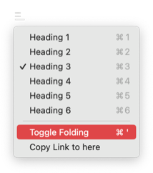
Sometimes it helps to hide sections of a note, whether they are a distraction, finished content, or triggering your writer’s block. You can hide any section with headings 1-6.

To hide the currently selected section of a note, click the icon next to the heading text, then click Toggle Folding. To expand a hidden section, click the … button next to the section’s name. Give it a try with the next section ⬇️.

Here’s a folded section you can play with →
Peekaboo!


Footnotes
Footnotes are a great way to expand on a topic or idea elsewhere in a note, or offer a source or link for more information (see most Wikipedia pages for examples).

To create a footnote in a Bear note:

- Place your cursor at the end of a word
- Click the BIU button > More Menu (⋮) > Insert Footnote
- Bear will add a footnote, like this, then navigate to the bottom of the note where you can add further explanation, a source, or anything else to the footnote’s reference

To navigate between a footnote and its reference at the bottom of a note, simply click its number between the brackets.

Sketching on iPad and iPhone
Sketching in Bear for iPad and iPhone now has an expandable canvas with different background options and uses the full PencilKit toolset. Both Apple Pencil and third-party styli are supported.

Table of Contents, Backlinks, and new Info Panel

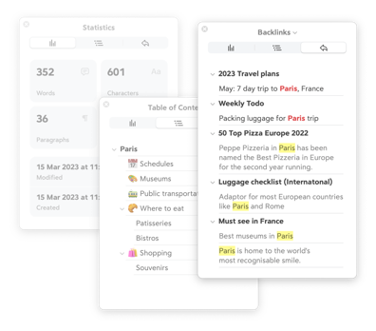

The ⓘ Info Panel (in the top right of a note) has been redesigned to be more compact and legible. It now has a second tab for a Table of Contents, which is automatically built based on any headings (H1-H6) in each note. A third tab contains Backlinks, a list of all notes that link to the current note.

Mac Tip: To keep the panel always visible, click and drag on the panel to ‘tear’ it away from the window.

The Note List
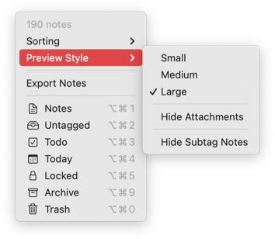
The Note List is now more flexible, thanks to a dedicated menu at the top. You have new sort options, control over note preview sizes, and can disable attachment thumbnails in the Note List.

If you want tags to behave more like folders, toggle the Hide Subtag Notes option. This means selecting a parent tag in the Sidebar will only display notes with that tag in the Note List and exclude notes from all child tags.

The Sidebar
A new tag edit panel makes it easier to change its name and now search for TagCons. Right-click (or long press on iOS) a tag to pin it to the top of the tags list for quick access.

Thanks!
Truly, thank you. The code-named Panda alpha test leading up to this was instrumental to the Bear 2 beta. We appreciate everyone helping us to make this the bear-iest Bear 2 it can be.

There is a lot new in Bear 2 and more great stuff planned post-launch, so be sure to leave your feedback in our beta forum and join our infrequent mailing list to stay on top of all things Bear.

#Bear

Footnotes? More like fun notes!
Learn more about footnotes at Wikipedia

